**Task Management System**

**1. Module Description**

The task management system is designed to streamline and enhance the efficiency of task management, project collaboration and of an organization.

**Objectives**

* Efficient task management
* Improved project collaboration
* Customization an integration

**Functionality**

* User authentication and authorization
* Dashboard – customizable dashboard for displaying tasks ,projects and deadlines
* Task creation and organization
* Project creation and management
* Task tracking
* Notifications and reminders - Robust search functionality to find tasks and projects quickly.
* Search and filters- Robust search functionality to find tasks and projects quickly.
* File attachments
* Reporting and analytics
* Mobile accessibility
* Server less backend
* Data security and backup
* Customization and integration

**Key components**

* Server less backend
* Database management
* Authentication and authorization

**2. Number of users**

**1. Admin**

* User creation and manage
* Add designation and manage
* Project creation and manage
* Assign project
* Add tasks and manage
* Assign task
* Add categories and manage
* Status view of project
* Status view of task
* View reports

**2. Manager**

* View Assigned Project
* Create team and manage
* Assign project to team
* Add task and manage
* Assign task to team
* Update project status
* View task status
* View report
* View notification

**3. Staff**

* View Assigned project
* View Assigned task
* Update task status
* View report
* View notifications and alerts

**3. Project activities**

* User Authentication and authorization (Day 1,2)
* Dashboard Designing (Day 3,4)
* Category creation and manage, Designation create and manage (Day 4,5)
* Project creation and manage (Day 6,7,8)
* Task creation and manage (Day 9-10)
* Status updation (day 11-13)
* Filter and search (day 14-17)
* Notifications (day 18-23)
* Reports(day 23-24)
* Project analyzing(day 24-25)
* Updation (day 25-27)

**4. Tables**

**1. Register**

|  |  |  |  |
| --- | --- | --- | --- |
| **Column** | **Datatype** | **Constraints** | **Description** |
| User ID | Integer(10) | Primary Key | To store user id |
| Username | String(50) | Not null | To store username |
| Email | String(50) | Unique | To store email |
| Contact | Integer(50) | Not null | To store contact |
| Role | String(50) | Not null | To store Role |
| Password | String(50) | Not null | To store password |
| Usertype | Integer(10) | Not null | To store usertype |

**2. Project**

|  |  |  |  |
| --- | --- | --- | --- |
| **Column** | **Datatype** | **Constraints** | **Description** |
| Project ID | Integer(10) | Primary key | To store project ID |
| Project name | String(50) | Not null | To store Project name |
| Description | String(500) | Not null | To store Project description |
| Start Date | Date | Not null | To store Project start date |
| Due Date | Date | Not null | To store due date of project |
| Current date | Date | Not null | To store Current date |
| Assigned Manger ID | Integer(10) | Foreign Key | To store manager id |
| Team ID | Integer(10) | Foreign Key | To store  Team id |
| Files | String | Not Null | To store  Files |

**3. Task**

|  |  |  |  |
| --- | --- | --- | --- |
| **Column** | **Datatype** | **Constraints** | **Description** |
| Task ID | Integer(10) | Primary key | To store task id |
| Task Title | String | Not null | To store Task title |
| Task Description | String | Not null | To store task description |
| Due Date | Date | Not null | To store due date |
| Current Date | Date | Not null | To store current date |
| Priority | String(50) | Not null | To store priority |
| Assigned  User ID | Integer(10) | Foreign Key | To store staff id |
| Assigned  Project ID | Integer(10) | Foreign Key | To store Project id |
| Category ID | Integer(10) | Foreign Key | To store Category  ID |

**4. Category**

|  |  |  |  |
| --- | --- | --- | --- |
| **Column** | **Datatype** | **Constraints** | **Description** |
| Category ID | Integer(10) | Primary key | To store  Category ID |
| Category name | String(50) | Not null | To store Category name |

**5. Team**

|  |  |  |  |
| --- | --- | --- | --- |
| **Column** | **Datatype** | **Constraints** | **Description** |
| Team ID | Integer(10) | Primary key | To store  Team ID |
| Team name | String(50) | Not null | To store Team  name |

**6. Team members**

|  |  |  |  |
| --- | --- | --- | --- |
| **Column** | **Datatype** | **Constraints** | **Description** |
| Team Members ID | Integer(10) | Primary Key | To store Team members id |
| Team ID | Integer(10) | Foreign Key | To store team id |
| Staff ID | Integer(10) | Foreign Key | To store members ID |

**7. Status**

|  |  |  |  |
| --- | --- | --- | --- |
| **Column** | **Datatype** | **Constraints** | **Description** |
| Status ID | Integer(10) | Primary Key | To store status ID |
| Current Status | String(50) | Not null | To store Current status |
| Message | String(500) | Not null | To store Message |
| Current date | Date | Not null | To store current date |
| Project ID | Integer(10) | Foreign Key | To store project ID |
| Task ID | Integer(10) | Foreign Key | To store Task ID |

**8. Designation**

|  |  |  |  |
| --- | --- | --- | --- |
| **Column** | **Datatype** | **Constraints** | **Description** |
| Designation ID | Integer(10) | Primary Key | To store  Designation id |
| Designation name | String(50) | Not null | To store designation name |

**5. Template**

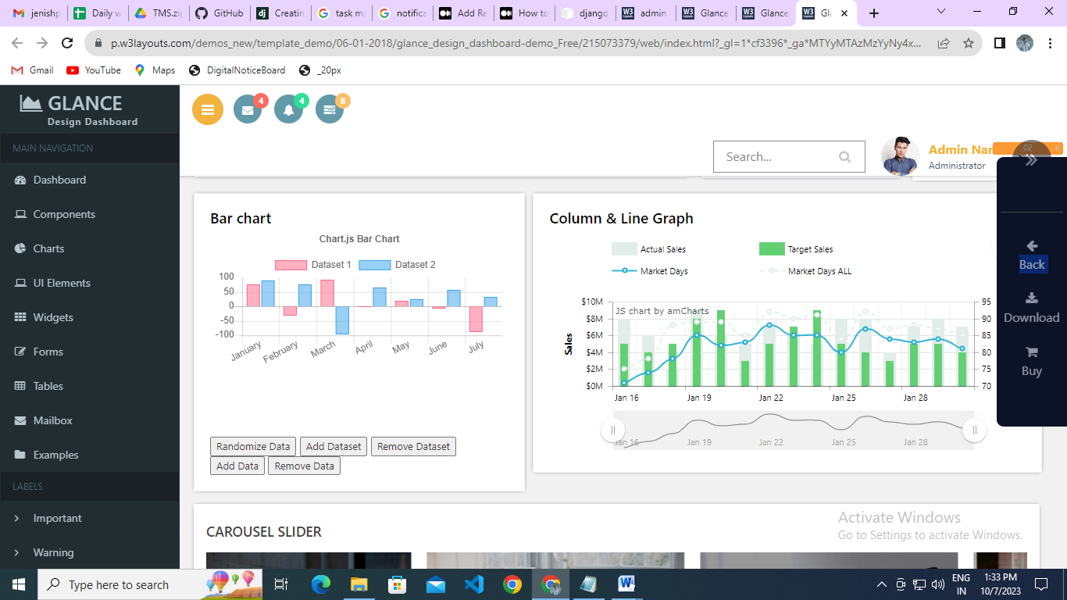

Admin

Logout

TMS

* Add Staff
* View Staff
* Add Designation
* View Designation
* Add Category
* View category
* Add Project
* View Project
* Add Task
* View Task
* Status view
* Report view

Manager

Notifications Logout

TMS

* View assign Project
* Add Task
* View Task
* Add Status
* View status
* Report view

Staff

Notifications Logout

TMS

* View assign Project
* Add Task
* View Task
* Add Status
* View status
* Report view

LOGIN FORM

Form

View Pages

Filter

SEARCH